ePledge Employee Guide
Purpose of this document: Walk through the steps in entering a pledge through the ePledge site and designating the gift and confirming the employee’s information.
If you have questions while completing your pledge or run into log in issues – please contact your Employee Campaign Coordinator (ECC) for assistance.
Please note the stars featured in areas where information is very important.

Accessing the e-Pledge Site:
An email is sent to each employee – this link provides direct access to each individual’s specific pledge information. Please do not share, forward, or delete that link, as it’s specific to you.
Emails are sent from the email box: epledge@unitedwayhp.org
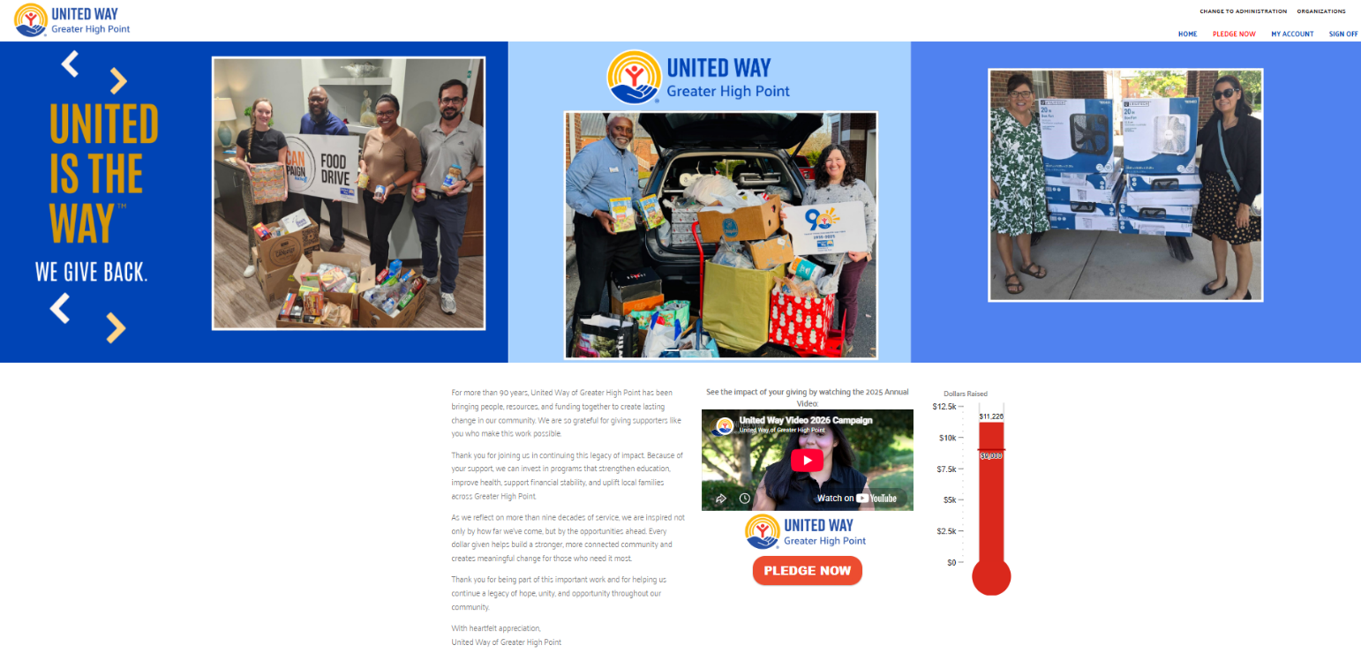
Should you delete the link on accident, forget the login, or have issues accessing it – please contact your Employee Campaign Coordinator.

Employees will enter a Pledge by clicking Pledge Now button at the top of the screen or choose the option at the top of the screen to Pledge Now.


- Within the menu, donors have the option to view “My Account” which includes your address and email address for confirmation of gifts.

Pledging – Click Pledge Now

Then Select Pledge Type
- Employee can select their preferred method of giving
  - Payroll Deduction, Credit Card, Direct Bill, Check, Cash, etc.
- Click Next
  - As you navigate through the site, you will use NEXT to move forward
  - Choose PREVIOUS to go back within the form
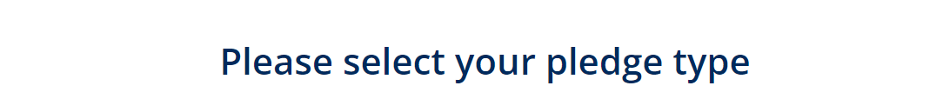
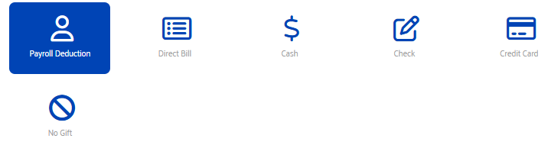

Enter Pledge Amount
- Based on your preference, you will choose one of the options: Payroll, Credit Card, Direct Bill, Check, or Cash.
  - If you select your “Caring Gift” – (defined as 1 hour of pay per month or 0.6% of your salary), you can use the calculation function after entering your Annual Salary and it will provide you with the deductions per pay period automatically
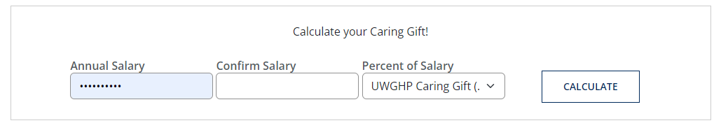
    - Note: Some companies will pre-populate the Caring Gift Amount for you based on your profile. If so, your information will be in the site preloaded.

Example of calculating a Caring Gift:
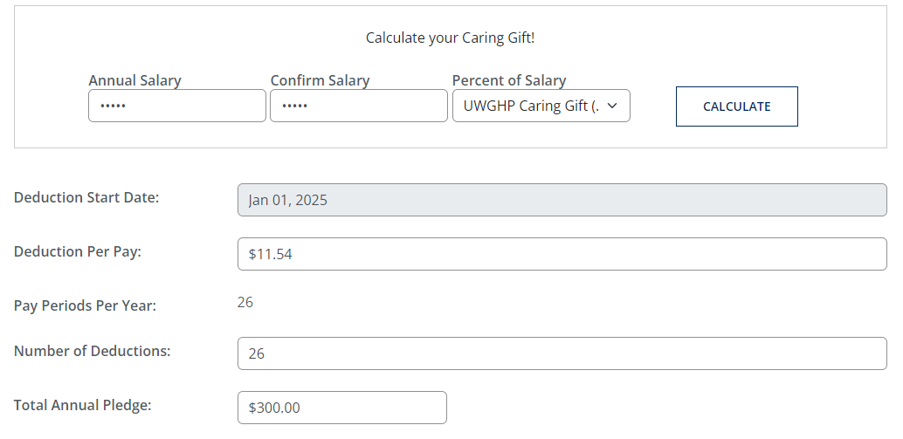
Change the number of deductions here based on your preferences. It will default to your total number of pay periods in the year.
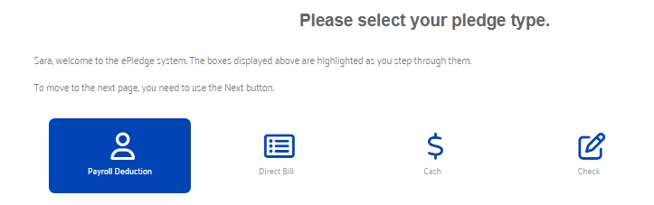

  - Payroll Deduction (2 options)
    - If you are pledging your Caring Gift, calculate, and then it will automatically populate the amount per pay period in the box for the number of deductions per pay period (based upon your company’s settings)
    - If you are selecting a different amount, choose your deduction amount and then select the number of payroll deductions (if you want to choose each pay period, it will auto populate, or you can choose a different number of deductions if you wish to do so).
  - For Direct Bill:
    - Choose the options presented based on your preferences
      - Annually, Semi-annually, Quarterly, or Monthly
  - Cash or Check Pledges:
    - After entering your pledge, give your contribution to your Employee Campaign Coordinator or HR representative
  - Credit Card Pledges
Please note that Credit Card payments will be processed on the same day.
We do request that credit card payments be $10.00 and up due to increased fees for processing.
    - Select the pledge amount, (use the Caring Gift calculation or type in the amount in the box)
    - Tab down to enter or verify your address after Designation Option first
      - New process - Credit Card pledges will default to the designation window, and then to the payment portion.
    - (Note: Once you click Confirm & Pay, you will be launched into a new screen where you will enter your card information).
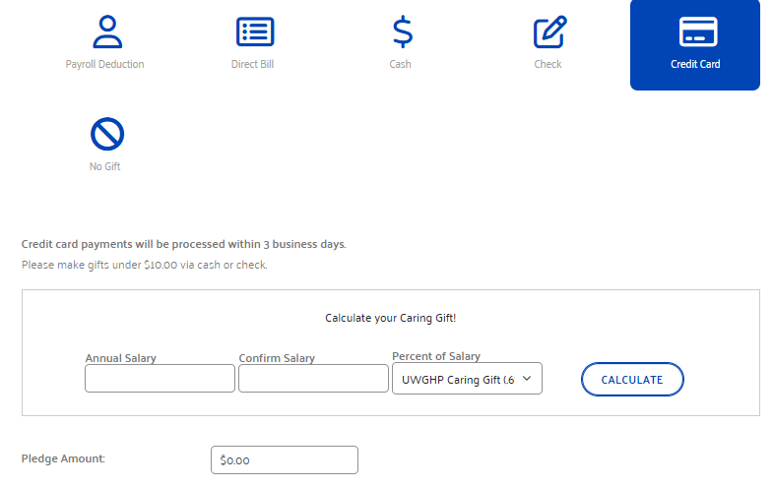
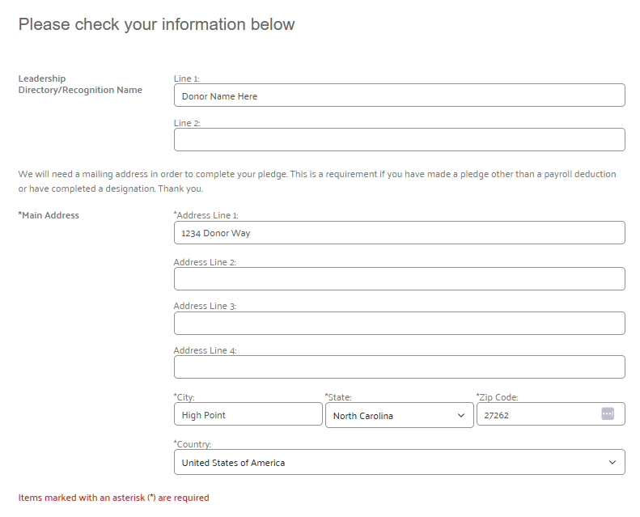

- After entering your Credit Card Pledge Amount, you will select Designations, if you would like to do so (detailed in the next section).
- Then, choose Continue
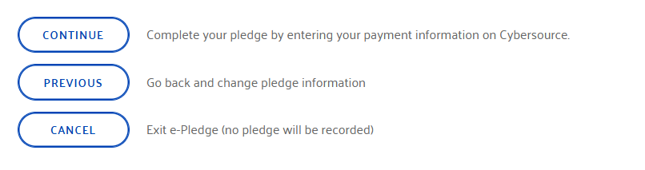
- A new screen will pop up and launch you into the Credit Card processing window.
- Please do not close the window or refresh – hold until the new screen populates.
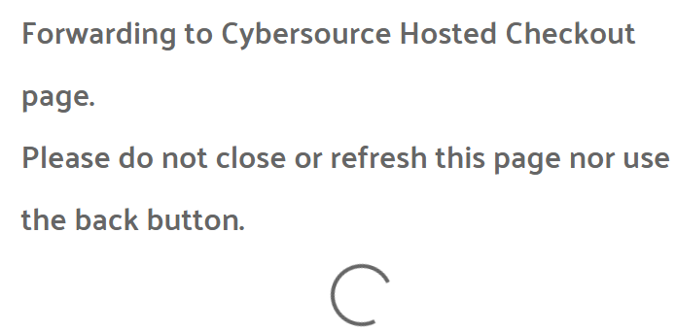
- Enter your Billing information and credit card details
- Click Pay
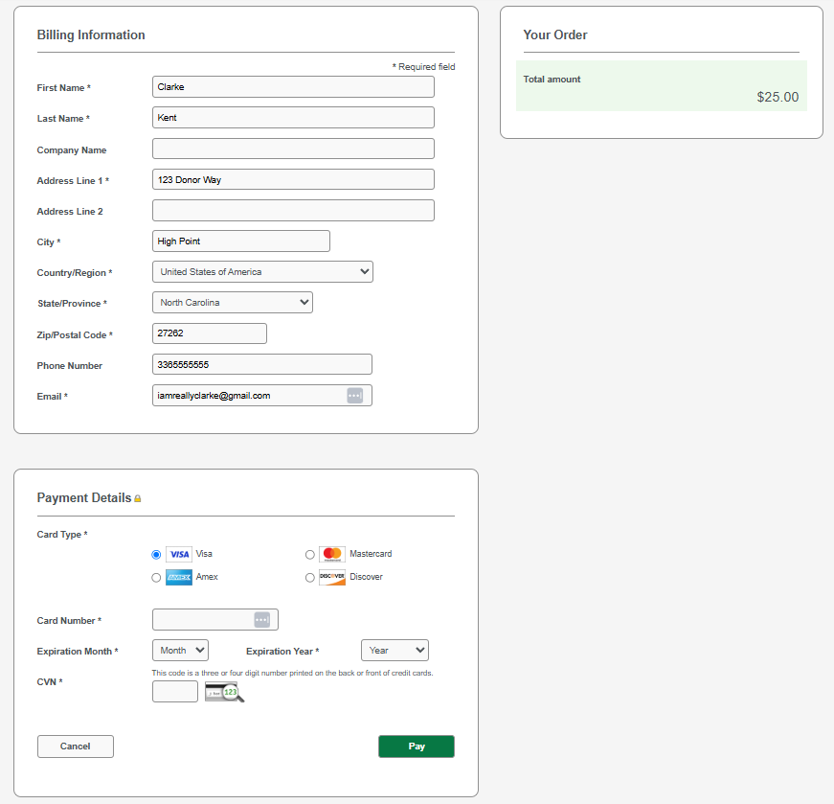

Designations
2). In the next section, you can choose to Designate your gift
  - Click on the > Designations portion to expand the window
    - Note: If no designation is established, the funds go where they are needed most in our community

Your total pledge amount will appear at the top of the page
  - It will update as you choose your designations
    - Note that a minimum of $100 is needed to designate, any pledges under $100 flow into our Community Action Fund
  - The counter at the top will tally or alert you if you have allocated more than you’ve pledged

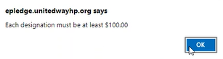

  - The first section in the Designation Window includes UWGHP Initiatives and Focus Areas
  - The second section allows for Agencies to be searched by Keyword
    - To find a partner agency – search by the keyword and then click the “+” sign to designate

  - The third section allows for a Write In option, if the desired agency or 501-(C)3 organization is not listed (providing as much detail as possible for the write in agency, ensures that we are able to honor your designation).
    - Provide the full agency name
    - Address, City, State, etc.
    - Amount you wish to designate – and Click ADD

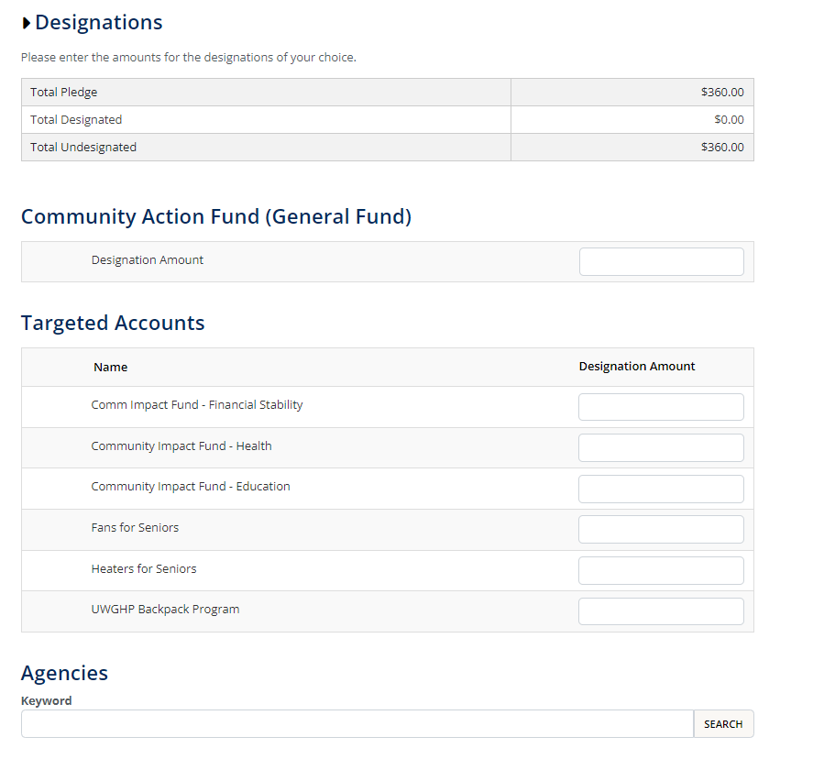

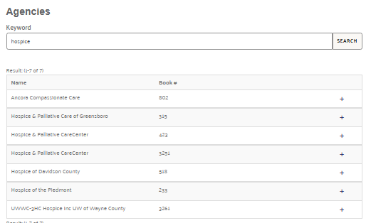
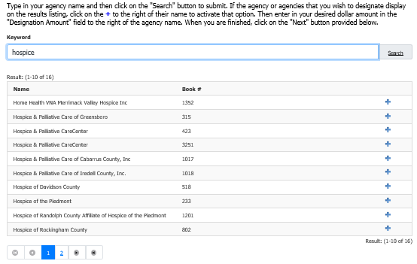
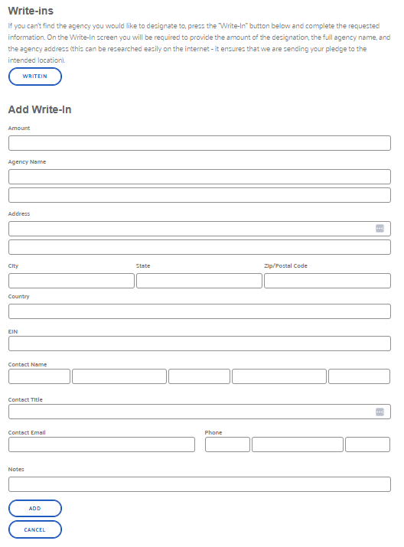

For Write In’s:
- Enter the amount of your gift
- Enter the Agency Name, Address, City, State, Zip
- Any notes
** This information is helpful to ensure that your fit is associated with the agency of your choice. **

Verification
- NOTE: The check box at the bottom asks if you wish to have your name released to the designated agency
    - Check ONLY ONE box to indicate your preference.
    - Share both my name and contact information to the non profit agency – so they can send a thank you.
    - Share only name, no thank you needed
    - Or, keep my gift anonymous – no information to be shared
      - Note: If you are pledging a Leadership Gift, your name will need to be changed to reflect Anonymous as well.
    - Check other boxes if applicable to your interests or gifts
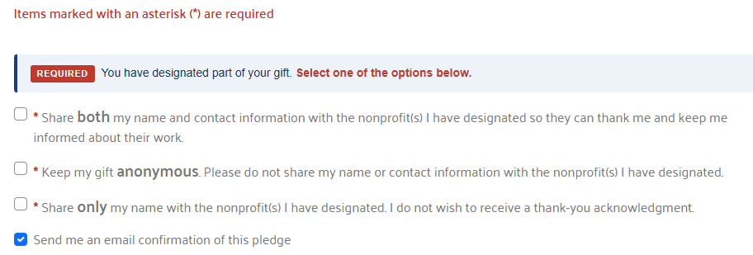

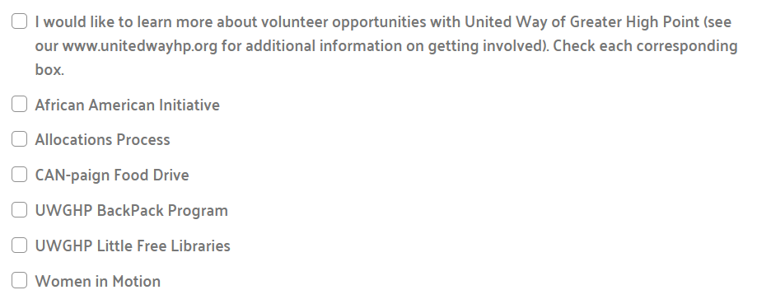

Leadership Gifts
- Gifts over $1,000 are categorized as a “Leadership Gift”
- These can include combined gifts with your spouse
  - Check the corresponding box below for combined gifts
  - Click the link for Combined Giving Form (see below)
- Very important!
    - Check the box to acknowledge the pledge – so we can thank you for your generous gift!
    - If you wish for your name to be listed as “Anonymous” – check the corresponding box
- Enter your mailing address (as shown in the previous section)
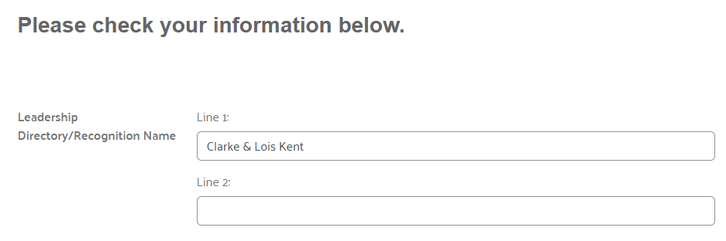

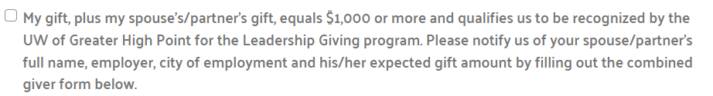

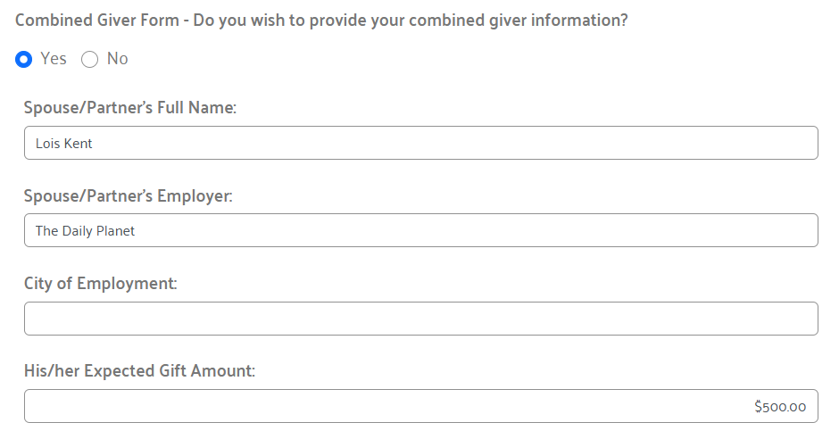

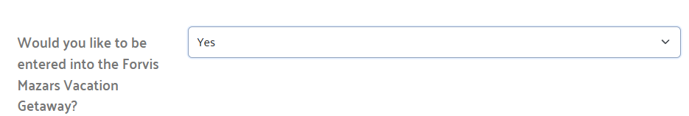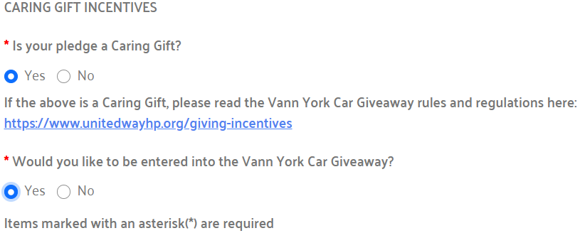
Don’t Forget! Check for Incentives, for the Vacation Getaway and the box for your Caring Gift and for the Car Raffle! You’ll be automatically entered into the raffle by checking YES.

Confirmation
- Review the pledge form and all details
- Verify that the information is correct as entered
- Confirm the Check Boxes associated with your pledge
  - Acknowledged designation (very important)
- If changes are needed, click previous to return to a section
- Click CONFIRM to record your pledge
  - Note: If you do not hit Confirm, your pledge will not be recorded.
- Print a copy for your records
- An email Thank You, and confirmation will be sent to you as well.
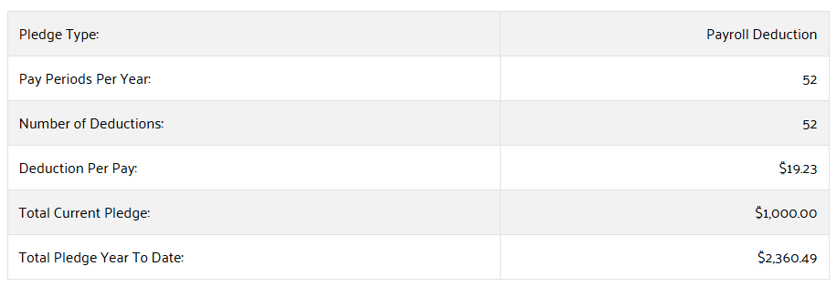
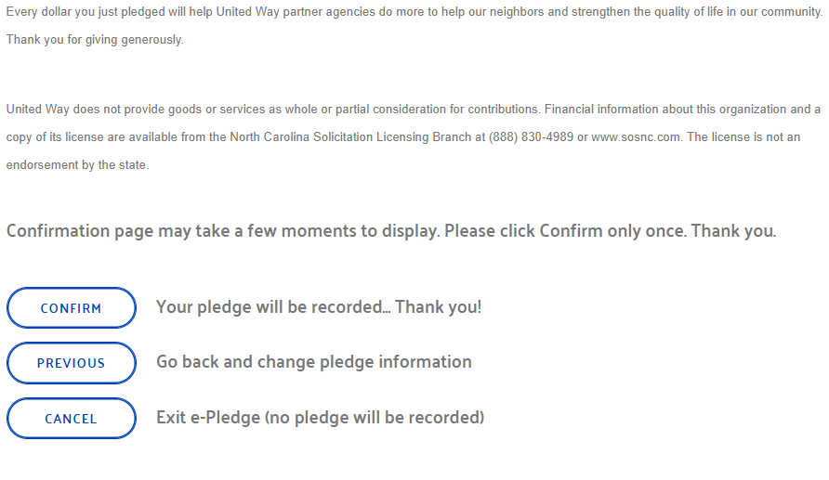

My Account
- Click to verify your personal information
- Update any changes to your address, phone number or email address
  - Update your Leadership Directory name
  - Personal Email address
  - Note that Workplace Details are defaulted by your company
- Allows you to change your password

Questions??
Need help with pledging or designations?
Call 336-883-4127 (ask for Sara, Will, Haley, or Amy)

