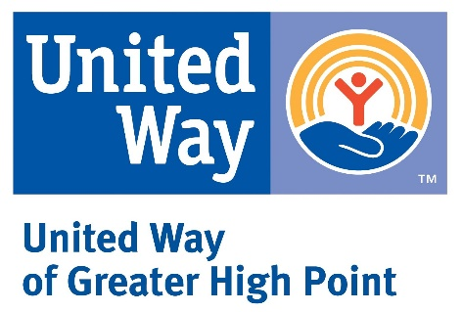
Give. Advocate. Volunteer.

LIVE UNITED

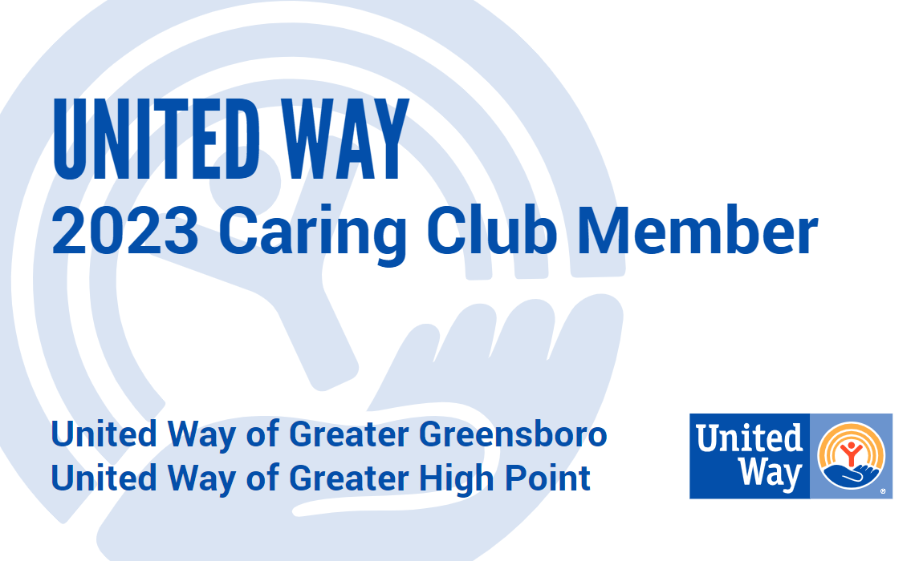

Account Number:

Account Name:

Total Number of Caring Gift Donors:

ECC Name:

ECC Phone Number:

- Please return this completed form in the blue campaign reporting envelope with your pledge forms.

- E-Pledge users: Please return the completed form with your final car raffle forms.

- Please keep a copy for your records.

- For more information on the Caring Club Card, visit our website: www.unitedwayhp.org

Thank you for your Caring Gifts!

